ITALIAN COFFEE HOURS
SPRING 2019
A NEW AND FUN EXPERIENCE
EVERY MONTH!

Monday January 28th  4:00 to 5:00 Decio Commons  PANE, NUTELLA E GIOCHI | Thursday February 21st  4:00 to 5:00 Decio Commons  CAFFÈ CON I NONNI ITALIANI
Monday March 4th  4:00 to 5:00 Decio Commons  FESTA DELLA DONNA E GIOCHI  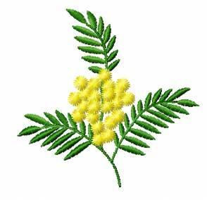 | April 1-4  JOIN US FOR INTERNATIONAL WEEK ACTIVITIES  