FREE YOGA CLASSES
IN ITALIAN
Spring 2019
In need of exercising, relaxing and keeping up with your Italian?
You can do all three in just one hour!
Classes will be conducted mostly in Italian with some English to illustrate poses.
With Professor of Italian and Registered Yoga instructor Tiziana Serafini.

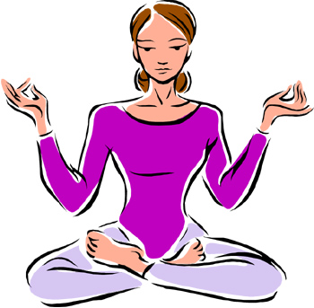

WHEN:
Friday, February 15 - 3:30-4:30pm.
Friday, March 22 - 3:30-4:30pm.
Wednesday, April 24 - 3:30-4:30pm.

WHERE:
Smith Center Studio 1

